Application Deployment
(Deploy the given react application to a production ready state)

Application:
Clone the below mentioned repo and deploy the application. (Run the application in port 80 [HTTP])
Repo URL : https://github.com/sriram-R-krishnan/devops-build

Docker:
- Dockerize the application by creating a Dockerfile
- Create a docker-compose file to use the above image

Bash Scripting:
Write 2 scripts
- build.sh – for building docker images
- deploy.sh – for deploying the image to server

Version Control:
- Push the code to GitHub to dev branch (use .dockerignore & .gitignore files)
- Note: Use only CLI for related git commands

Docker Hub:
- Create 2 repos "dev" and "prod" to push images
- “Prod” repo must be private and “dev” repo can be public

Jenkins:
- Install and configure Jenkins build steps as per needs to build, push & deploy the application
- Connect Jenkins to the GitHub repo with auto build trigger from both dev & master branch
- If code pushed to dev branch, docker image must build and pushed to dev repo in Docker Hub
- If dev merged to master, then docker image must be pushed to prod repo in docker hub.
AWS:
Launch a t2.micro instance and deploy the created application.
Configure Security Group (SG) as below:
- Whoever has the IP address can access the application
- Login to server can should be made only from your IP address

Monitoring:
- Setup a monitoring system to check the health status of the application (open-source)
- Sending notifications only if the application goes down is highly appreciated

Submission:
- GitHub repo URL, deployed site URL, and Docker image names must be included in the submission
- Upload the screenshots of the below items to the GitHub repo:
  - Jenkins (login page, configuration settings, execute step commands)
  - AWS (EC2 Console, SG configs)
  - Docker Hub repo with image tags
  - Deployed site page
  - Monitoring health check status

- GitHub repo URL, deployed site URL, and Docker image names must be included in the submission
https://github.com/sridhar20ece/devops-build.git
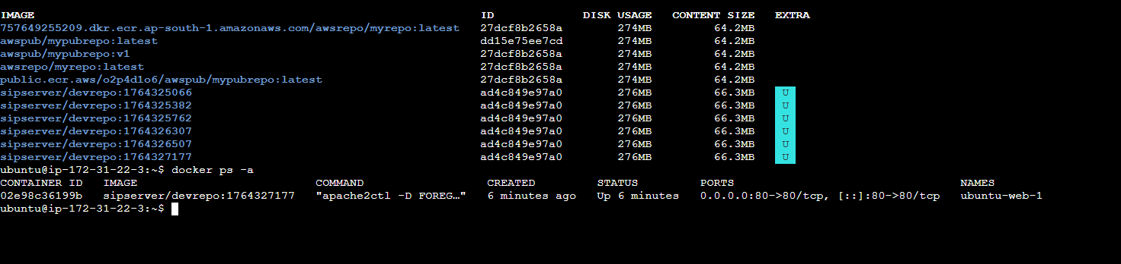

Site URL:
http://13.205.4.145/
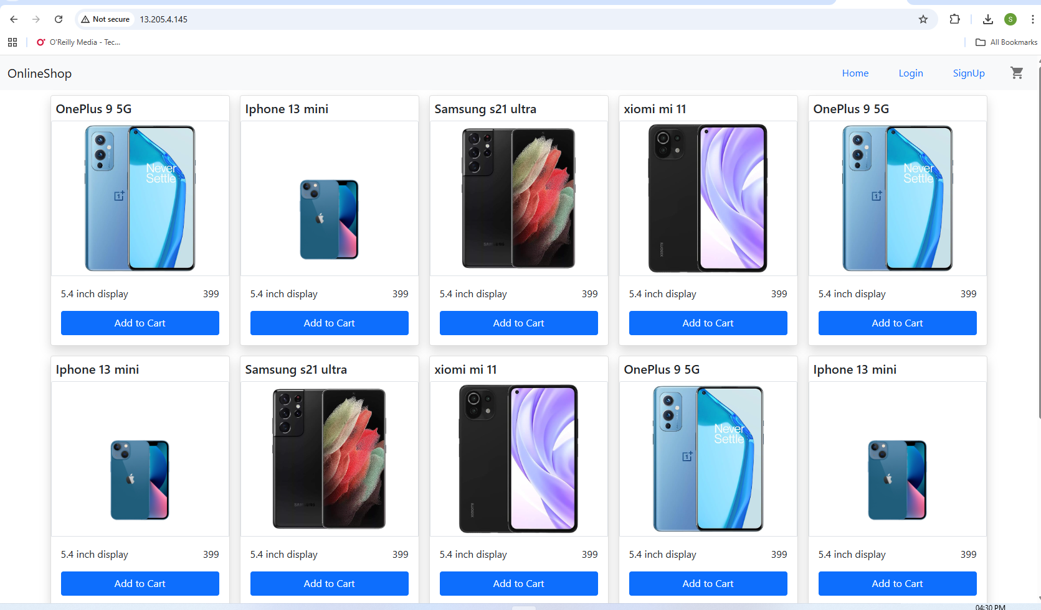
  - Jenkins (login page, configuration settings, execute step commands)
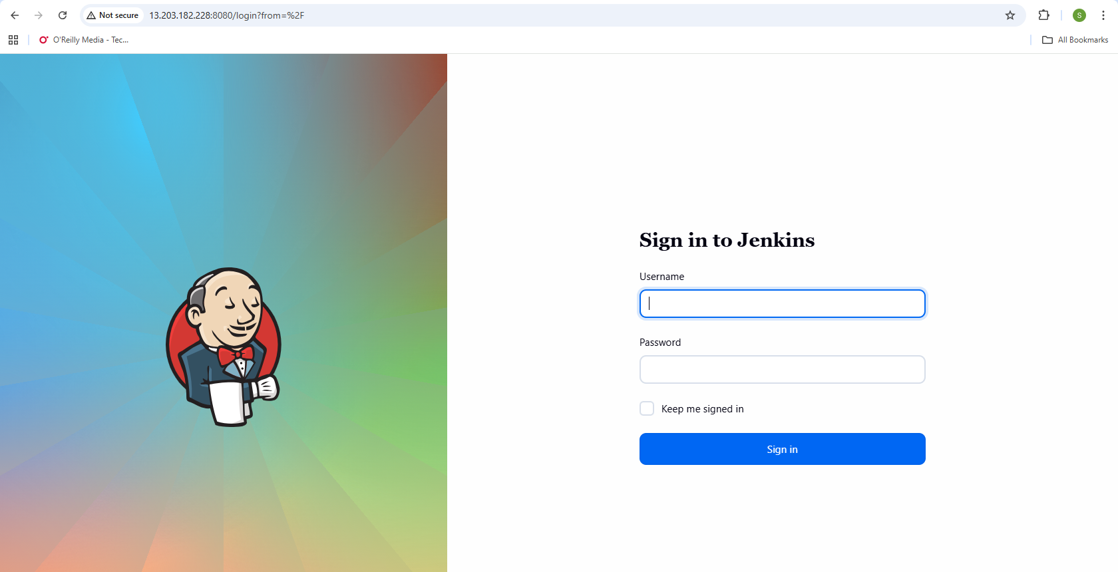
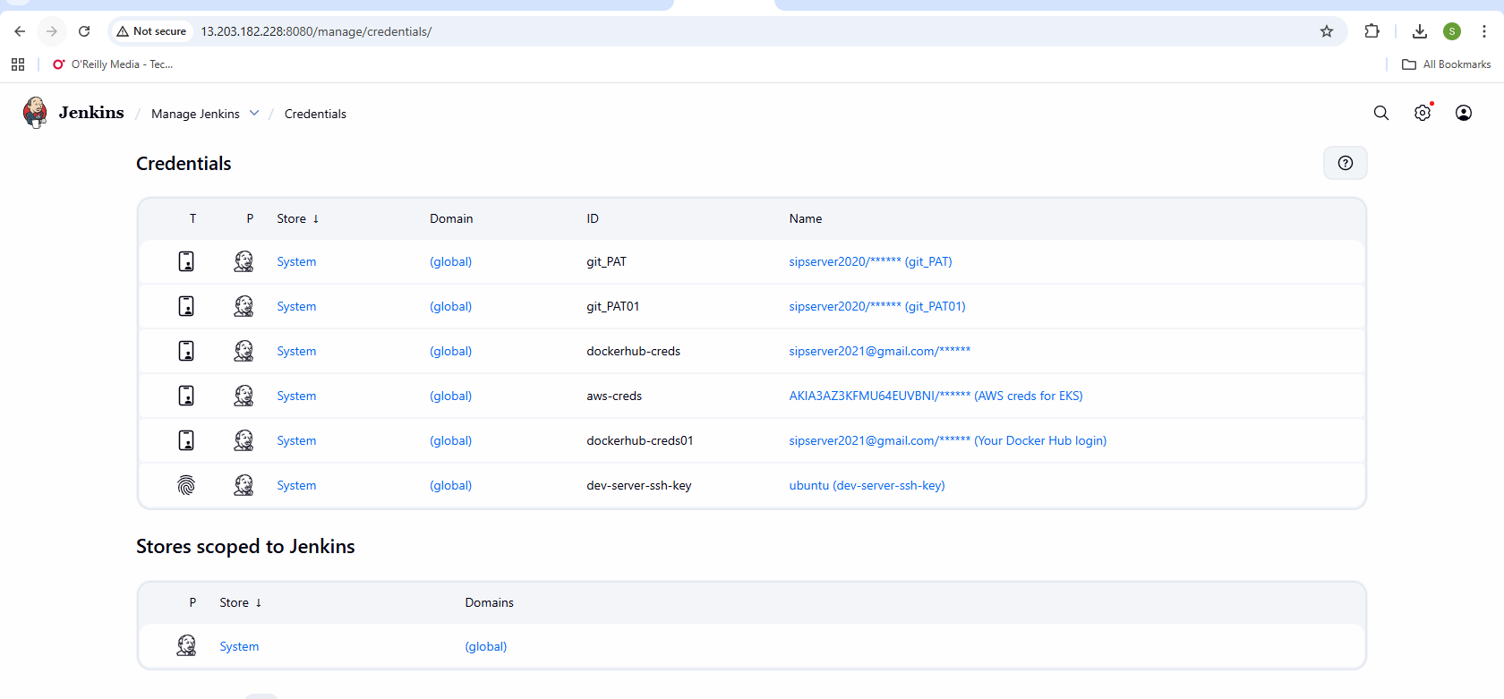
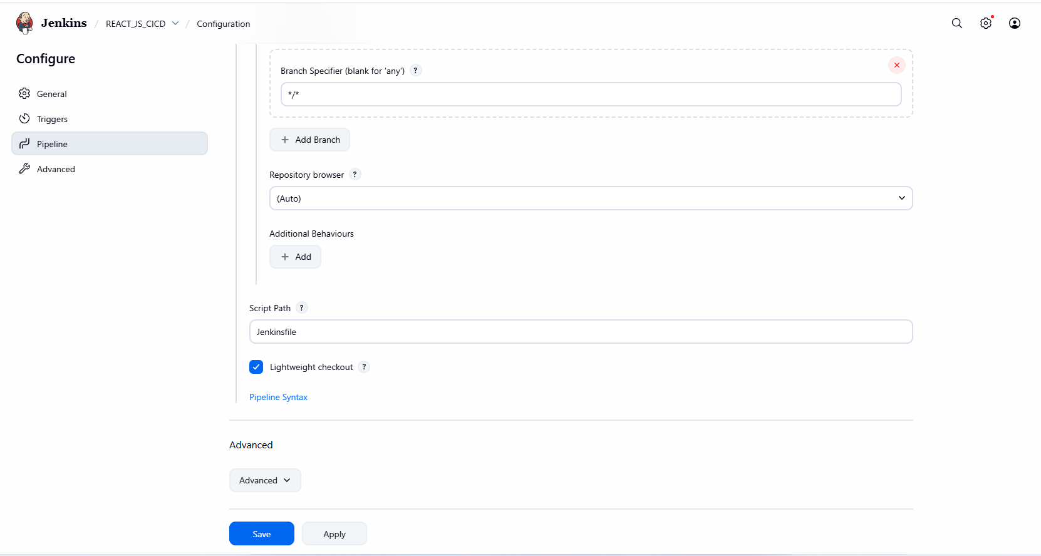
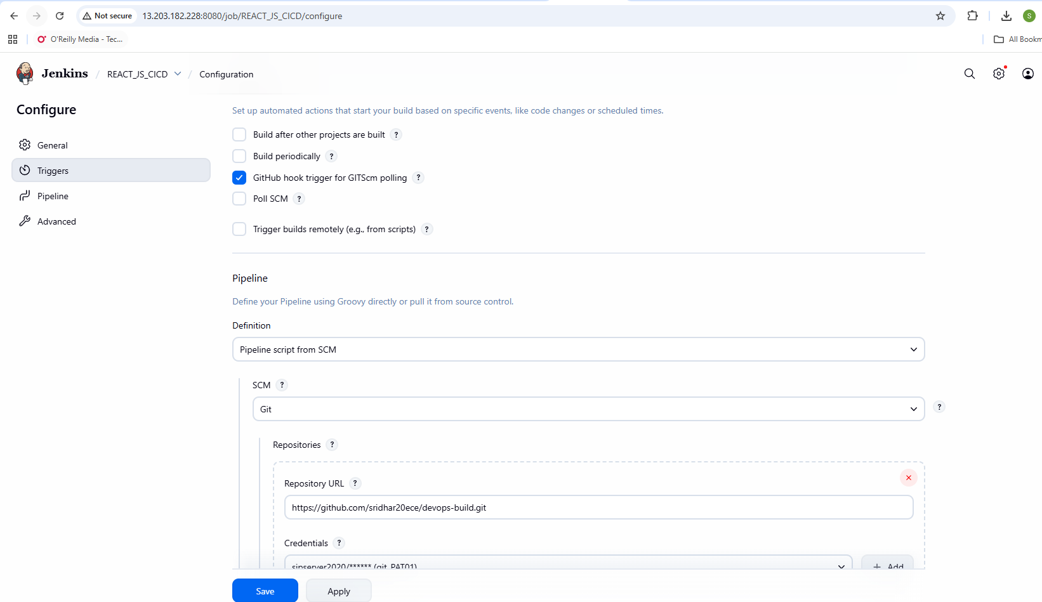
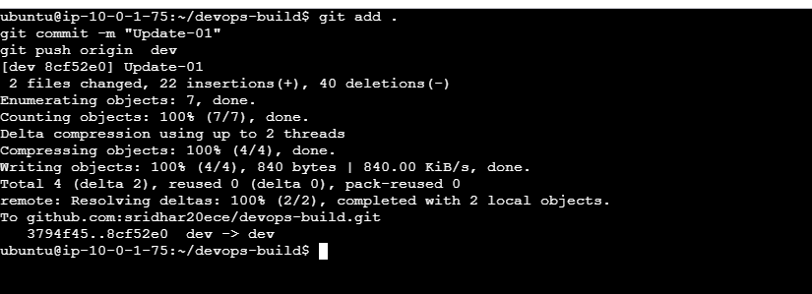
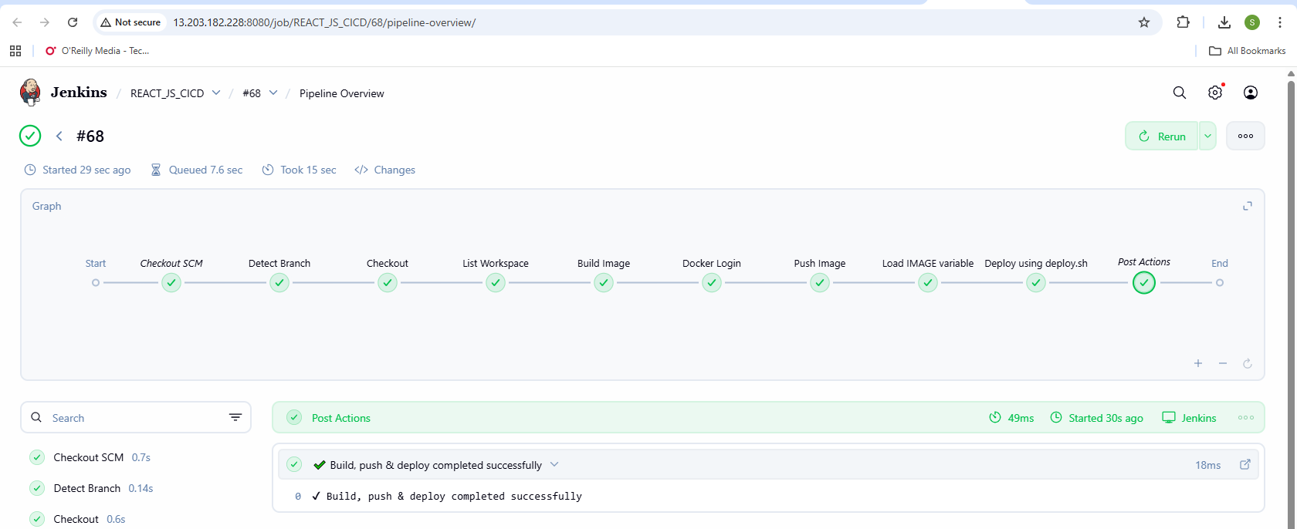
AWS (EC2 Console, SG configs)
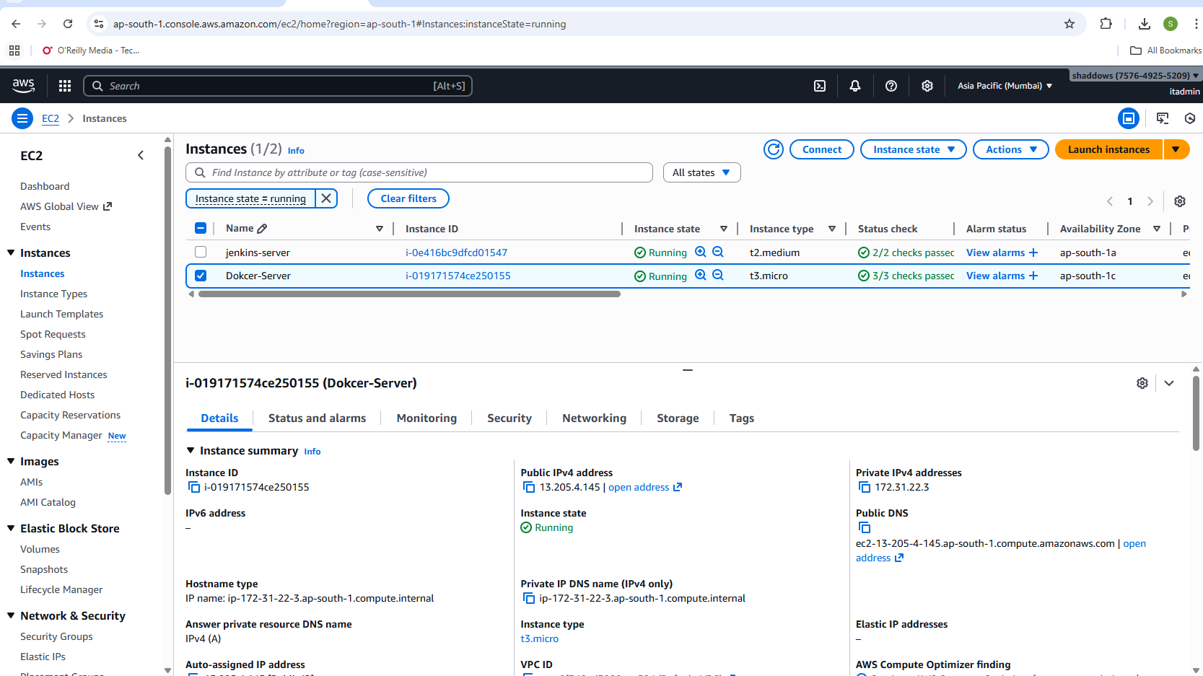
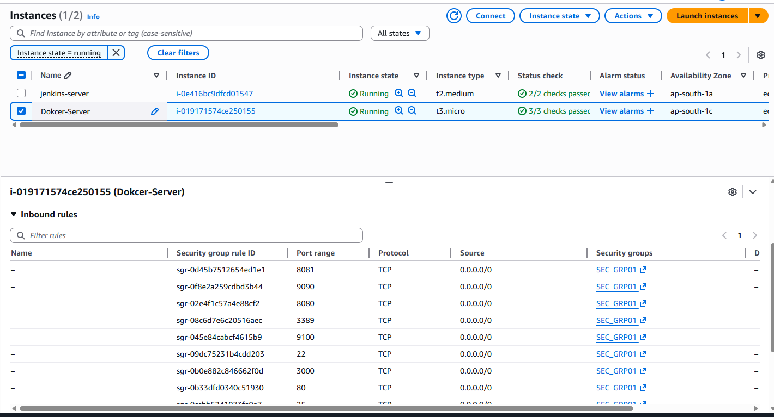
Docker Hub repo with image tags
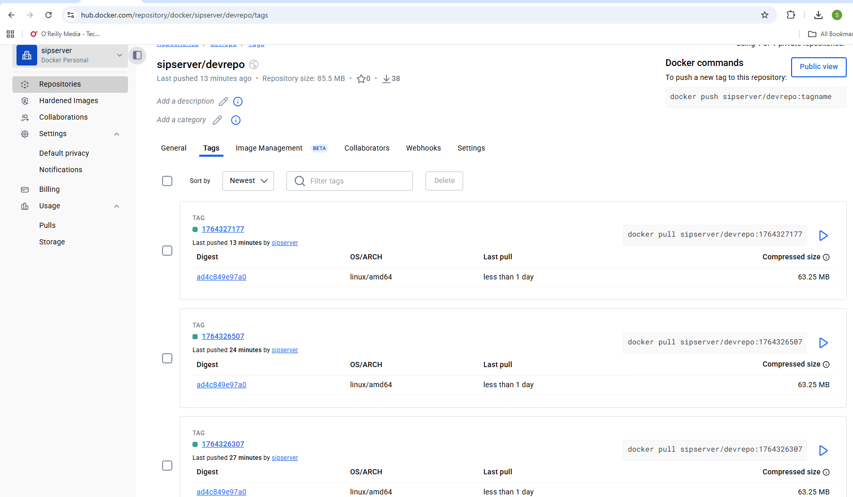
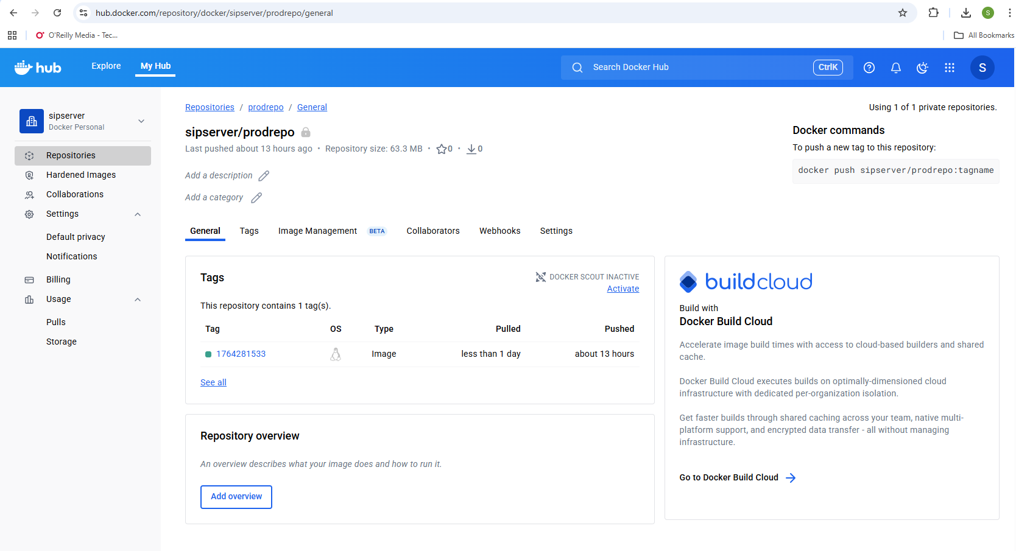
Deployed site page
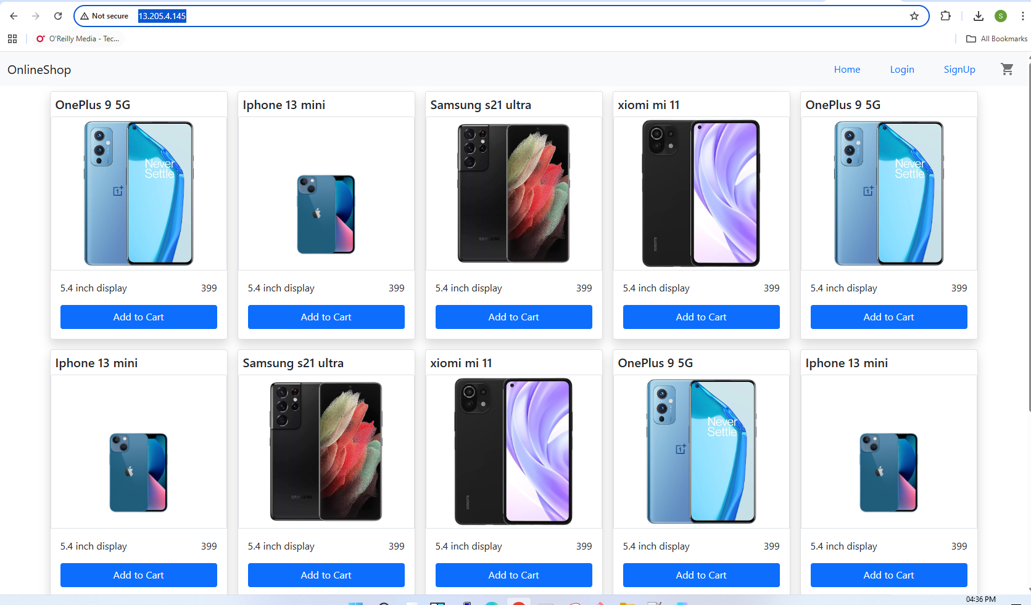
Monitoring health check status
